Report Submitted by

Sikakollu N V S K Prasanth (116CS0213)  
Uttam Singh (116CS0238)

**Indoor positioning system**

Progress Report

**Product Development Laboratory-I**

**Mid-Sem Evaluation**

**TITLE: “ INDOOR POSITIONING SYSTEM “**

**Submitted to:**

**Prof. Sujata Mohanty**

**Report Submitted By:**

**1. Sikakollu N V S K Prasanth (116cs0213)**

**2. Uttam Singh (116cs0238)**

**INDOOR POSITIONING SYSTEM**

**Contents:**

1. Introduction
2. Motivation
3. Objective
4. Hardware used
5. Algorithms used
6. Work done so far
7. Implementation and analysis
8. Conclusion

**Introduction:**

Indoor localization is a fundamental service for various location based applications. Despite the extensive research and development of indoor position systems, location based services are not yet ubiquitous indoors.

Localization of objects or living things or their navigation has always been a primary human concern. Indoor Positioning system can be used to track a person in indoor.

Main challenges of indoor positioning are the limitations of the technologies available. While many existing indoor localization systems are active assemblies based on methods such as ultrasound, radio or optical waves, each of these has its own assets and drawbacks.

Various methods are used for IPS .These include:

1. Using IMU(sensor)
2. Using Wi-Fi finger printing
3. Using Bluetooth Finger printing
4. WLAN or RFID based technologies

Here in this project, we use the IPS with IMU sensor.

**Motivation:**

As the technology has developed day by day, the GPS (Global Positioning System) served the best purpose of localization. The GPS systems fail to track the locations in indoors due to two major

reasons:

1. The GPS localization takes place via microwave radiations and in indoors due to high attenuation through concrete walls, the signals are weakened.
2. The GPS works only when the device supporting the GPS architecture and the satellite are in Line Of Sight (LOS) communication, which is not possible in indoors.
3. GPS system has low precision.

Therefore, when it comes to indoor positioning, other alternatives such as Bluetooth, Wi-Fi, RFID and Infrared based techniques.

**Objective:**

The main objective of our project is to track a person inside a large concrete building. This project focuses on integration of low cost Inertial Measurement Unit (IMU) in order to improve the system’s positioning update rate (when compared to other IPS methods) and therefore provide a 2-D localization estimates for kinematic applications.

**Hardware used:**

1. **Inertial Measurement Unit (IMU):**

GY-521 MPU -6050 Module 3 axis Gyro + 3 axis Accelerometer module for Arduino.

**2. Arduino Board:**

UNO R3 AT mega 328p.

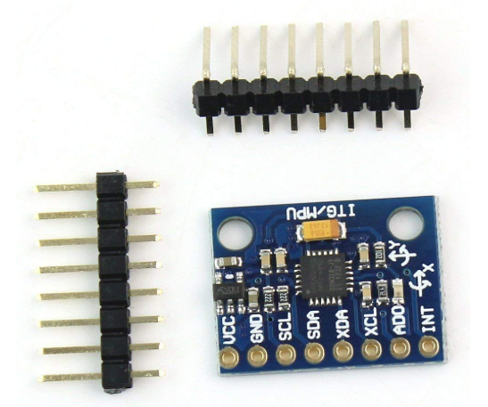

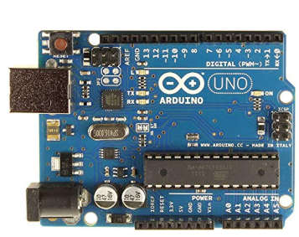

**Algorithms used:**

1. **Kalman filter:**

The data obtained from IMU is highly affected with noise and if used for prediction may lead to wrong results. So first we preprocess the data by using Kalman Filter. It implements a predictor-corrector type estimator that is optimal in the sense that it minimizes the estimated error when presumed conditions are met.

Kalman filter is carried out in two steps:

1. Predict and

2. Update.

2. **Numerical Integration methods:**

The data obtained from IMU basically gives the accelerations in X,Y and Z co-ordinates but the Kalman filter requires the data of acceleration and velocity. So we use Numerical Integration methods to calculate the velocities and thereby predicting position of the person.

**Work done so far:**

1. We have interfaced the Arduino board with the IMU unit.
2. Arduino board was programmed for the data collection

process using Arduino Software.

1. Data was collected by mounting the entire hardware on the

shoes of the person to be tracked.

1. Numerical methods of integration have been applied to the

data collected and velocities are obtained.

1. Data is being preprocessed using Kalman filter.

The results obtained from Kalman filter were not very much satisfactory, so work is being done on improving the algorithm to obtain better results for prediction.

**Implementation and Analysis:**

The collected data was plotted using matplotlib library of python. The plot is as shown in the figure.

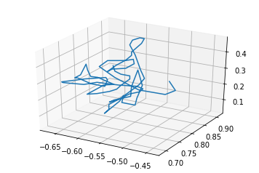

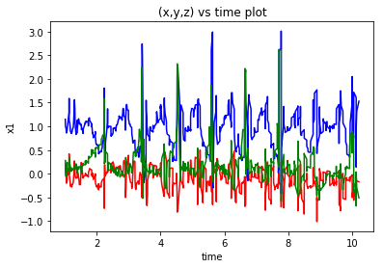

**Conclusion:**

In this contribution the aim was to present an indoor positioning system for kinematic applications by using sensor fusion. Due to high extent of noise in the data collected, the above plots seems to be less relevant for tracking and hence the work is being carried out to develop an extended form of Kalman filter to reduce the data corruption for better estimation of position of the person.